SUMMER PROGRAMS/OPPORTUNITIES – 2026

Kids Connection
Kids Connection Summer Day Camp offers a fun-filled summer for kids who have completed Kindergarten through Grade 6!
Campers enjoy exciting field trips, community visitors, energetic gym games, lots of outdoor time, and creative crafts and activities in a safe, welcoming environment.
It’s the perfect place to make friends, stay active, and have fun all summer long!

Register at: http://www.kidsconnection.ca
Questions? Contact Shirley at kidsconnection.ca

Our Before and After School programs provide a vibrant and safe "home base" where kids can unwind and connect with friends. We focus on meaningful, hands-on activities that keep kids energized, from creative DIY projects to active team games. We have a large outdoor play area and a full size gym!

Summer Program: Heroes, High-Energy, and Road Trips! 🚒💦
​Get ready for a summer where the action never stops! We’re bringing the community to us with weekly visits from special guest experts. Imagine your child meeting real-life Firefighters, chatting with the RCMP, or learning from members of the Military. It’s a front-row seat to see the gear, hear the stories, and discover what it’s like to be a local hero through hands-on, engaging experiences.
​When we aren't meeting heroes at the center, we’re hitting the road for two day trips every single week! We’ll be beating the heat at local pools and splash pads, exploring the best playgrounds, and heading to indoor fun centers for high-energy play. This program is for children who have completed Kindergarten through Grade 6. Spaces fill up fast, so email or contact us today to secure your spot for the ultimate Island adventure!

Before & After School: The Best Part of the School Day! 🎒
​The school bell is just the beginning of the fun! Our Before and After School programs provide a vibrant and safe "home base" where kids can unwind and connect with friends. We focus on meaningful, hands-on activities that keep kids energized, from creative DIY projects to active team games. It’s more than just child care; it’s a community where every student feels like they belong.
​Designed for children from Kindergarten completion through Grade 6, our program is the perfect bridge between home and the classroom. We make sure every morning starts with a smile and every afternoon ends on a high note. To learn more about our daily schedule and enrollment, reach out to us via email or phone for more details.

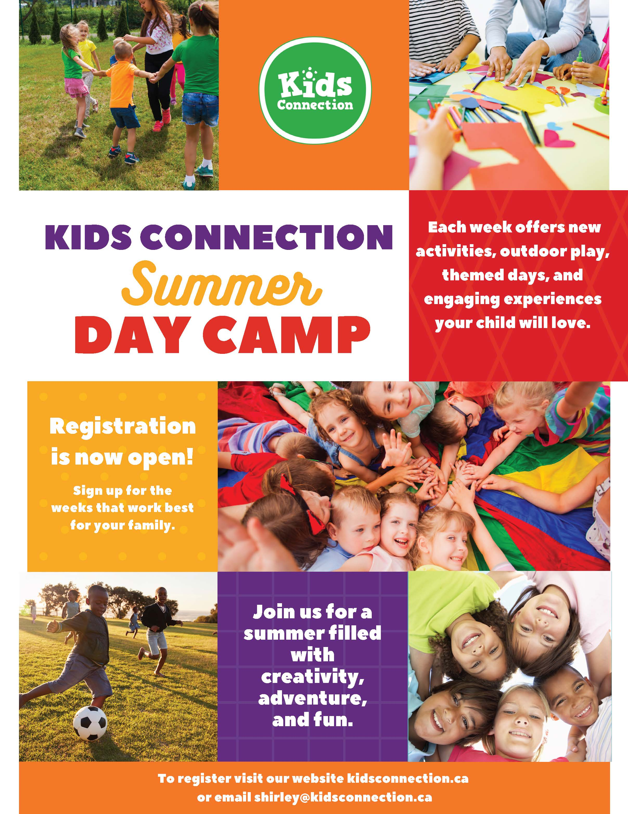

Holland College Canes Camp
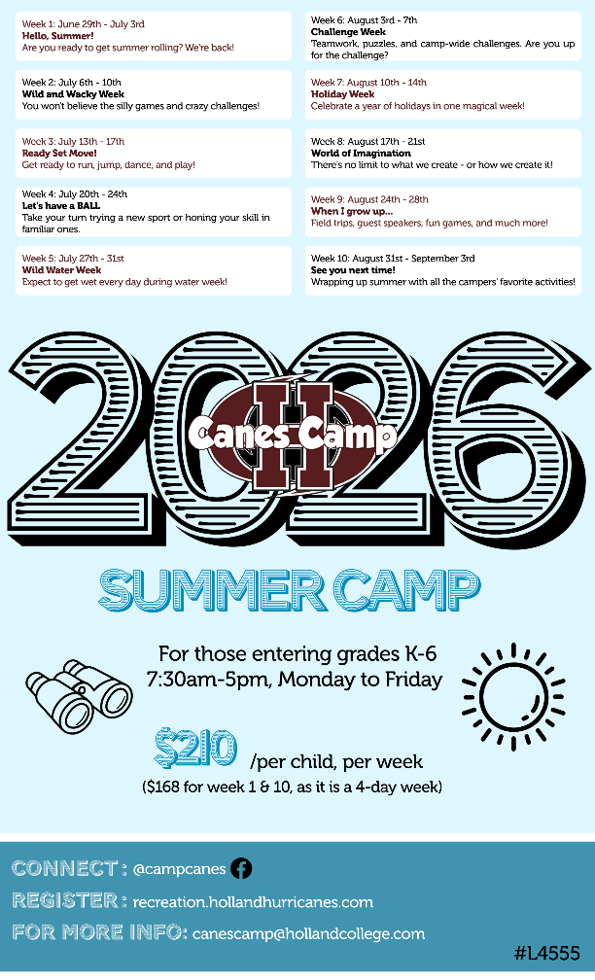
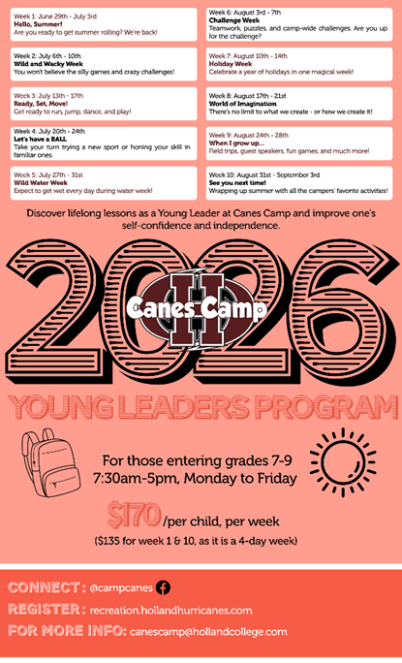

Rise and Climb Adventure Course
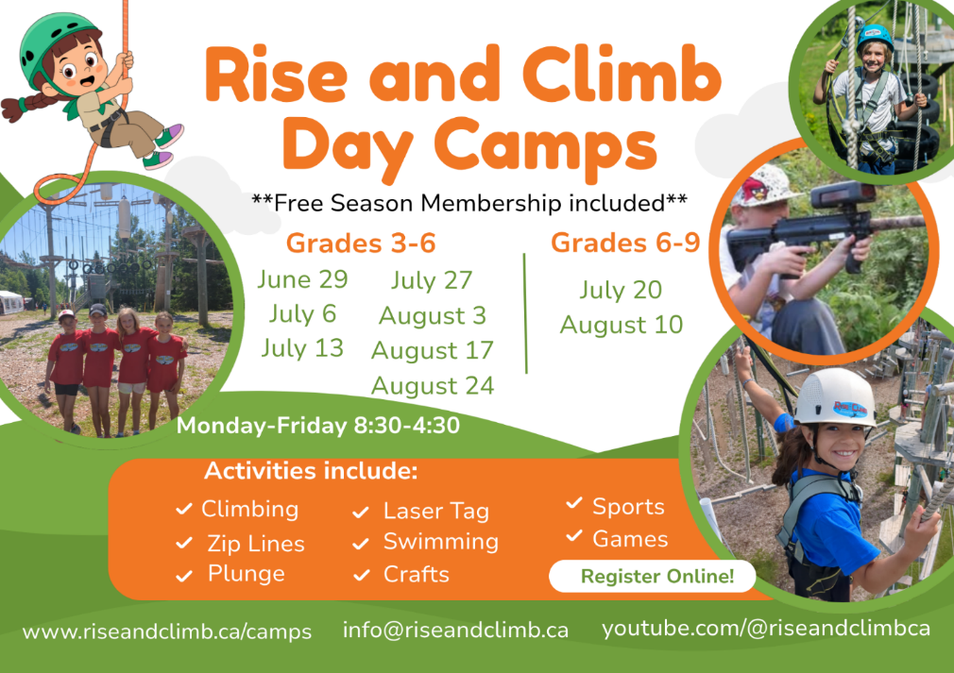
Offering summer day camps for youth completing grades 3-8 in Cornwall. Camps run Monday to Friday from 8:30 to 4:30 each day (extended hours available). Climbing, laser tag, sports, games, swimming and crafts! Free climbing membership included in registration.
Day Camps normally run a full week from Monday to Friday. Drop off is 8:30am and pickup is 4:30pm.
The fee is $239.99 which includes a Free Season Membership that's active as soon as payment is complete.
Register Online Now!!

Day Camps | Grades  (completed by June) | Dates | Fee | Status
Camp #1 | Grades 3-6 | Jun 30 - Jul 4 | $239.99 | Open
Camp #2 | Grades 3-6 | July 7-11 | $239.99 | Open
Camp #3 | Grades 3-6 | July 14-18 | $239.99 | Open
Camp #4 | Grades 3-6 | July 21-25 | $239.99 | Open
Camp #5 | Grades 6-9 | July 28-Aug 1 | $239.99 | Open
Camp #6 | Grades 3-6 | Aug 4-8 | $239.99 | Open
Camp #7 | Grades 3-6 | Aug 11-15 | $239.99 | Open
Camp #8 | Grades 3-6 | Aug 18-22 | $239.99 | Open
Visit www.riseandclimb.ca/camps for more information or to register.

KidHub Summer Camp
We’re excited to offer Summer Camps during your child’s school vacation! At KidHub, we create a fun, safe, and relaxed environment where every day is filled with engaging activities, friendships, and memorable experiences.
For more details and to explore programs for your child, visit our website: https://kidhub.ca"

CHARLOTTETOWN PARKS AND RECREATION DEPARTMENT
SUMMER DAY CAMPS
The Parks and Recreation Department is excited to bring back its Summer Day Camps for another fantastic season! The camps offer 9 weeks of action-packed adventures at two great locations: the Malcolm Darrach Community Centre and the Simmons Sports Centre. Each week features exciting themes and a variety of activities ensuring there's something for every child to enjoy. From sports to crafts to outdoor adventures, the fun never ends at our summer camps. There’s something for every child to enjoy, making our summer camps the perfect place for unforgettable memories.

Registration: May 5th at 9:00 AM (ONLINE ONLY)
Registration Fee: $138.00 City Resident & $158.00 Non-Resident
$148.00 City Resident & $168.00 Non-Resident (Swimming Lessons & Day Trip Weeks)
- There is a $25 non-refundable deposit due at the time of registration for each week a child is registered for.

OUTDOOR ADVENTURE 1-DAY CAMPS (AGES 11-15)
This is the 23rd summer for the Charlottetown Parks and Recreation Department to be offering Outdoor Adventure Camps for youth ages 11-15 years old. There will be several one-day camps offered during July and August, offering
activities such as paintball, kayaking, deep sea fishing, high ropes course and more! Camp dates and details will be available late May. Please note that lunch and snacks are provided for all Outdoor Adventure Camps.

Registration: June 4th at 9:00 AM (ONLINE ONLY)
Registration Fee: $52 City Resident & $62 Non-Resident per 1-day camp

YOUTH SUMMER PROGRAMS
The City of Charlottetown Parks and Recreation Department also offers a variety of recreation programs to keep kids active and engaged such as First Tee Golf, PLAE Multisport, Pickleball, swimming lessons, and more—there’s something for every age.
Programs focus on fun, skill development, and staying active in a safe and welcoming environment.

Registration for summer programs opens May 12th at 9:00 AM (ONLINE & IN PERSON).

For additional information on the City of Charlottetown Parks and Recreation Department programs, please check out the Spring & Summer Program Brochure here: https://www.charlottetown.ca/leisure___recreation/programs_and_activities/program_brochure

Camp Abegweit Day Camp
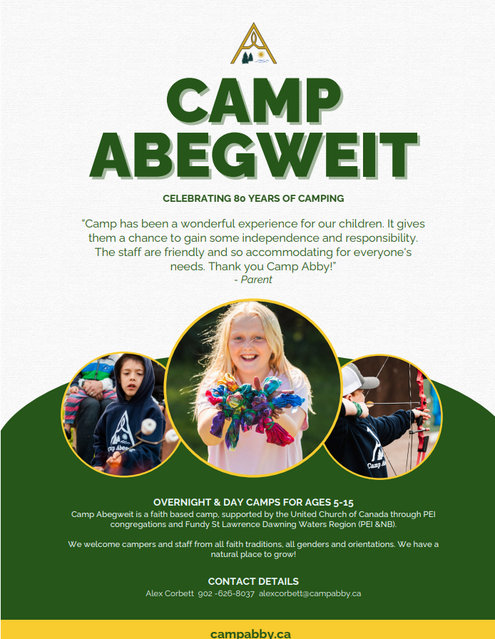
Alex Corbett
902-626-8037
alexcorbett@campabby.ca
https://campabby.ca

ISLAND GYMNASTICS ACADEMY
The Island Gymnastics Academy, located at the House of Sport / Royalty Centre at 40 Enman Crescent, Charlottetown, will be offering 8 weeks of full-day Summer Camps this year.
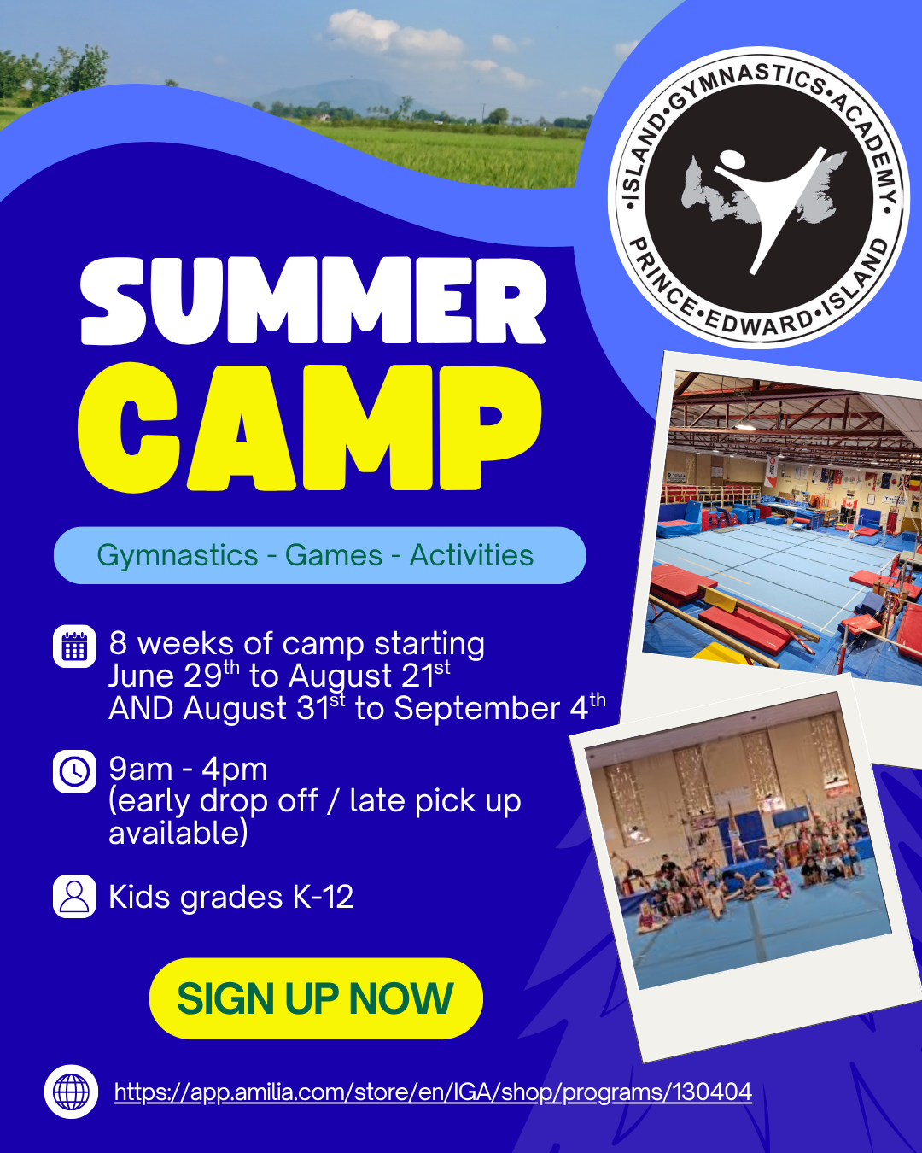

2026 TD SUMMER READING CLUB
Do you like cool stuff, amazing facts and mysterious fiction? 
Join the PEI Public Library Service at one of our twenty-six libraries across PEI to participate in the TD Summer Reading Club, Canada’s biggest, bilingual summer reading program for kids of all ages, interests, and abilities!

Be sure to stop by your local library for excellent reading suggestions from our friendly staff, as well as lots of exciting programs and activities! There’s something for everyone, from babies to teens!

For more information, visit library.pe.ca or follow us on Facebook (facebook.com/PEILibrary), Twitter (@PEILibrary) or Instagram (@peilibrary).

Prince County  Alberton Public Library | 902-231-2090
Bibliothèque J.-Henri-Blanchard | 902-432-2748
Bibliothèque Publique d’Abram Village | 902-854-2491
Borden-Carleton Public Library | 902-437-6492
Kensington Heritage Library | 902-836-3721
Kinkora Public Library | 902-887-2172
O’Leary Public Library | 902-859-8788
Summerside Rotary Library | 902-436-7323
Tignish Public Library | 902-882-7363
Tyne Valley Public Library | 902-831-3338
Queens County
Breadalbane Public Library | 902-964-2520
Charlottetown Library Learning Centre | 902-368-4642
Cornwall Public Library | 902-629-8415
Crapaud Public Library | 902-658-2297
Hunter River Memorial Library | 902-964-2800
Mount Stewart Public Library | 902-676-2050
Stratford Public Library | 902-569-7441
Kings County
Georgetown Genevieve Soloman Memorial Library | 902-652-2832
Montague Rotary Library | 902-838-2928
Morell Public Library | 902-961-3389
Murray Harbour Public Library | 902-962-3875
Murray River Public Library | 902-962-2667
St. Peter’s Public Library | 902-961-3415
Souris Public Library | 902-687-2157

Steam PEI
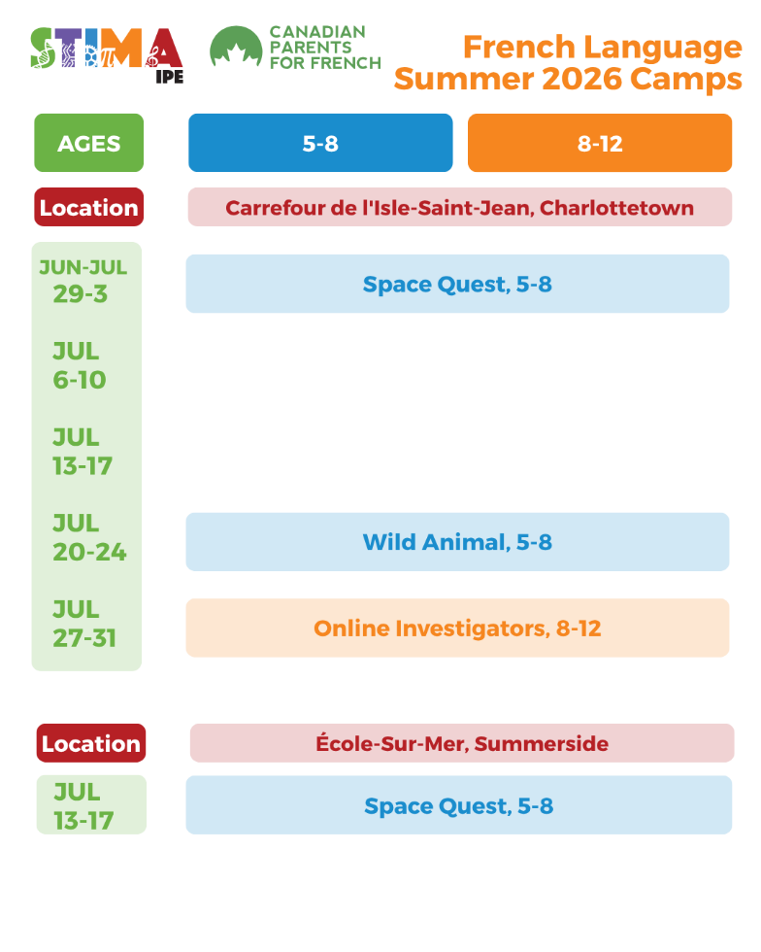
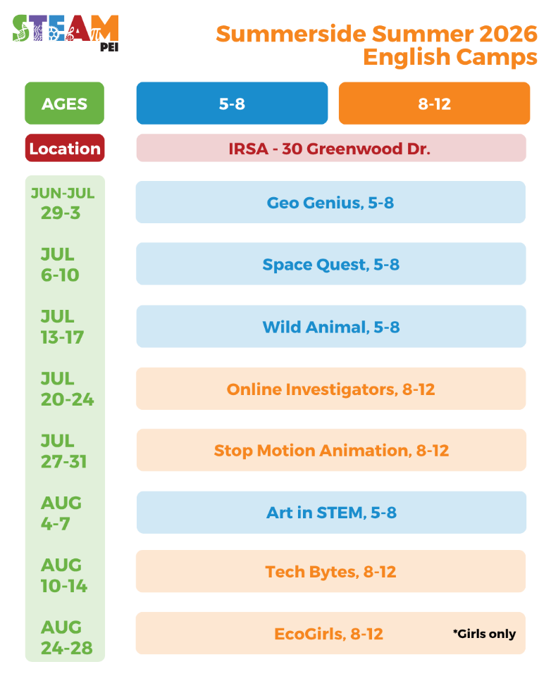
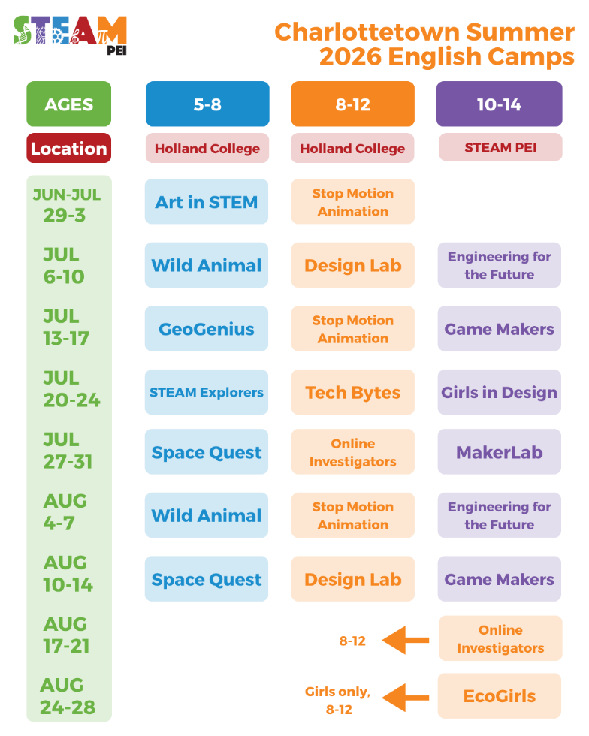
STEAM PEI's science, technology, engineering, art, and math camps are being held in Charlottetown and Summerside various weeks through the summer. Camps are available for students ages 5-8, 8-12 and 10-14. STEAM PEI offers a diverse range of themed week-long March Break and Summer Camps in science, technology, engineering, art, and math (STEAM) for youth across Prince Edward Island. Find more info and register at www.steampei.com
Contact admin@steampei.com or 902-201-4734.

Wild Child PEI
Join us this Summer as we explore and play in the great outdoors! We will enjoy P.E.I.’s beautiful nature spaces while we play games, create art and explore the meadows, forests, beaches and ponds. We are excited to build forts and friendships, learn how to climb trees, use tools and practice bushcraft skills. With so many plants, bugs and animals to see, we can’t wait to learn even more about the complex and incredible ecosystem that lives outside of our doors! The wonder of Summer awaits us!

Tales of Islandia – Active Roleplaying event

Runs weekly Fridays 4-6pm between May 29th and June 26th. Youth 8-14 are welcome to participate, and older youth are welcome to volunteer.

"Tales of Islandia is an imagination-centered, story-telling, live action role playing (LARP), nature-based program for creative youth. Wild Child and PEERS Alliance use the world of Islandia (created by Josie Baker) to mix different worlds together and create an inclusive non-judgmental world for all creatures and magics.

Our aim is to use live action role playing games to expand and grow skills with fun adventures. Some activities include team-building exercises and theater/improv games. We learn about consent and how it fits into imagination games and roleplaying. Given creative opportunities, kids are encouraged to make cosplay crafts, world build and create their own character lore.

This program is run in partnership between PEI Wild Child and PEERS Alliance."

Wild Child Roots & Shoots Day Camp:
July 20– July 24 *five day week*, 9:00-4:00, at Robert Cotton Park, for 6–15 year-olds.
Cost: Free thanks to our incredible funders.
PLEASE NOTE THAT THIS IS A CAMP FOR TRANS AND GENDER-DIVERSE/GENDER-CREATIVE CHILDREN (AND THEIR cis-gendered SIBLINGS).

Join us for a week of adventure and fun with Wild Child! This is a program run by 2SLGBTQ+ and ally staff who strive to create a comfortable environment and supportive community where kids can build confidence, make new friends, and are free to be themselves.

Walk The Earth day camps (for indigenous children):
‘Kwe/Hello! Please email us at peiwildchild@sierraclub.ca if you’d like your child(ren) to come to the Walk The Earth day camps that PEI Wild Child and the Mi’kmaq Family Resource Centre are running this summer! Space is limited, so once you register, we will let you know if your child(ren) are accepted into the program! If the program has already filled up, then they will be put on the waitlist. These camps are free thanks to our wonderful and generous funders. The first camp will run June 29, June 30- July 2, July 3 *Four Day Week, for 9 to 12 year-olds. THIS CAMP IS ONLY FOR INDIGENOUS CHILDREN -To register, please contact peiwildchild@sierraclub to express interest.

Day Camps:

About our camps: We invite you to an adventure-filled week exploring the many natural spaces in the park, making nature art, playing games, building forts, trying bushcraft challenges, learning about plants and animals, reading books from Sammy the squirrel, and making new friends! Our programs are founded on Forest School principles of child-led, inquiry-based experiences and free/unstructured play, with opportunities to try riskier outdoor activities under the supervision and support of our caring staff. We spend the whole day outside, rain or shine (except in dangerous weather)! At midday, we have lunch and a quiet time break where each camper gets their own hammock. We have access to an indoor washroom and water bottle refill station at Robert Cotton Park; in Summerside, we do not, so we will bring a camping toilet, privacy tent, and extra water and hand sanitizer.

Runs from June 29 – August 28

Go to https://peiwildchild.wordpress.com/ for registration and camp details

Camp Triumph
SEND A KID TO CAMP TRIUMPH

Who: Camp Triumph’s summer programs are for children aged 7-16 who have a family member with a chronic Illness or disability.
What: An overnight summer camp providing opportunities for these children to experience new activities, relax, gain new skills, and build relationships with those who truly understand. We have a focus on healthy active living and outdoor play.
Where: Malpeque, Prince Edward Island
Why: It’s something just for them. A chance for their needs to be recognized and met when they so often take a backseat. For their worries to wait at the door as they concentrate on trying new things, making friends, and having fun. We give them the opportunity to also build core life skills like confidence, self-esteem, positive coping strategies, problem solving, and resilience.
Cost: FREE
More Information: Visit our website, www.camptriumph.ca
How to register: Online, here: www.camptriumph.ca/applications
Camp Dates
Session One (Leadership Camp): July 15 - 25
Session Two: July 19 - 25
Session Three: July 26 - August 1
Session Four (Leadership Camp): August 5 - 15
Session Five: August 9 - 15
Session Six: August 16 – 22

BGC Charlottetown
BGC Charlottetown offers summer day camp programs for children ages 5 to 12 during the school holidays. Programs run from 7:30am-5:30pm Monday to Friday in a licensed facility from July to September. Campers participate in a fun-filled structured day of programming highlighted by:
Programming
• Beach Trips
• Pool Trips
• Park Trips
• Library Trips
• Guest Speakers
• Picnics and BBQ’s
• 2 Nutritious Snacks Daily
• Arts and Crafts
• Science Experiments
Our facility operates with a superb child to staff ratio and works with families to ensure individual needs are met.
Current Rates
$150.00 per week per child
Go to Summer Camp - BGC Charlottetown to register

Peers Alliance – Camp Aspen
Camp Aspen 2026
A 2SLGBTQIA+ Youth Summer Camp for ages 14 - 18
Camp Aspen is a four-day, three-night sleep-away camp designed by and for 2SLGBTQ+ youth and allies. Camp Aspen offers diverse workshops, activities, and games that empower gender-diverse youth while fostering a safe space for all. Check out peersalliance.ca to register!

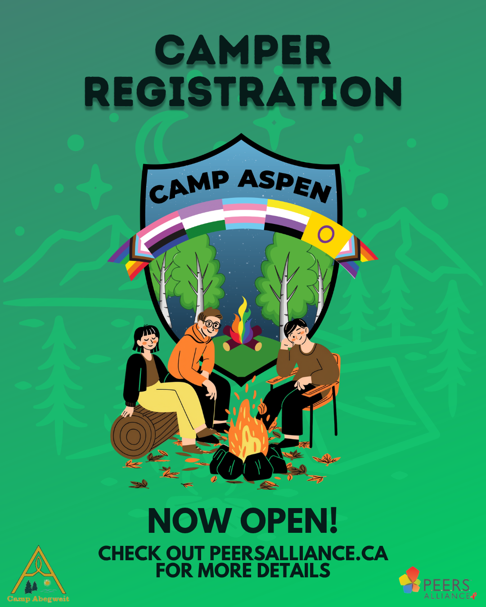

- Venture Stables
Venture Stables offers a variety of summer programs for children and youth, including:
- Summer Horse Camps
- Pony Rides
- Mobile Pony Parties
- Trail Rides
- Volunteer Opportunities for Teens
Our programs focus on building confidence, responsibility, connection, and a love of horses in a fun and supportive environment.
You can learn more and book online at venturestables.com
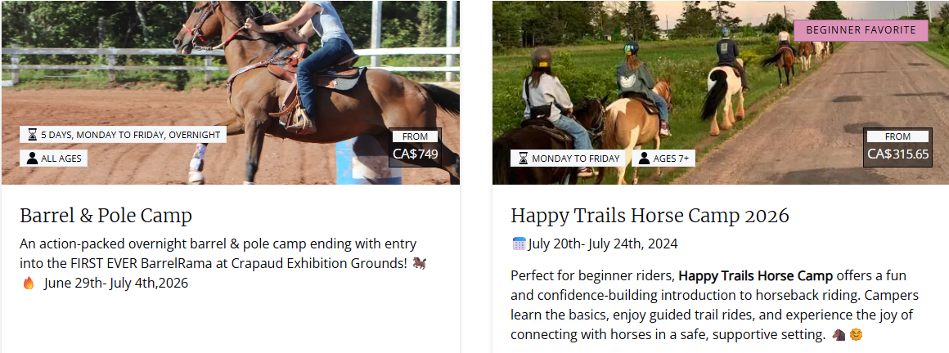
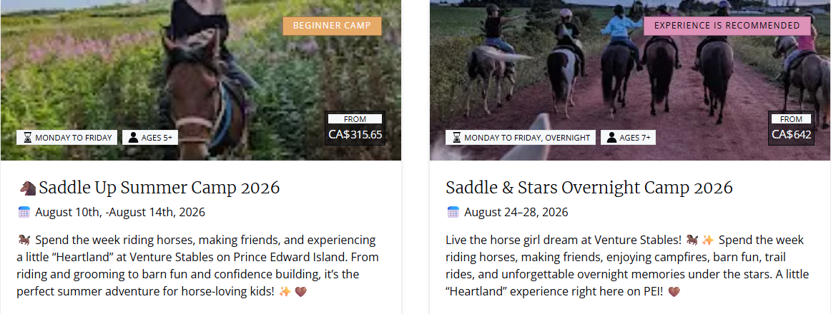

- Island Rock Camp
Camp Registration – Summer 2026
Our team is dedicated to a top-notch learning environment where young musicians can have fun while learning music!
This year’s camps:
Week One: July 6 – 10 Monday to Friday
Week Two: July 13 – 17 Monday to Friday
Week Three: July 20 – 24 Monday to Friday
OG Rock Camp
Age Range: 9 – 16
Our original rock camps were founded on the belief that students can learn from their peers at all ages, and that music transcends age. These camps provide a great environment for students of different ages and different skill levels to learn and make music together!
All experience levels are welcome, ranging from students with absolutely no experience playing an instrument, to students who have been taking lessons for a number of years.
This mixed environment allows students to learn from each other. Bands are typically divided based on age, playing level and instrumentation. Students are welcome and encouraged to try new instruments throughout the week!
Advanced Rock Camp
Age Range: 14 – 18
Advanced Camp has been developed for students who are keen on taking their musicianship to the next level. In addition to playing with a band and preparing a concert, students will also have lessons focusing on the music industry, marketing, recording and grant writing.
Experience on a principal instrument is required and audition videos can be sent to audition@islandrockcamps.com.

Songwriting Camp
Age Range: 14 – 18
Writing music is not something you are born with, but is a skill that is developed through practice and watching other great songwritings.
This camp is designed for students who have an interest in creating their own original content, this can include writing lyrics, chords, melodies and improvising.
During this camp students will be challenged with quick writes, co-writes, will experience workshops from local professional songwriters, and will learn to think about music in a new way.
Junior Song Camp
Age Range: 9 – 12
Junior Song Camp is a fantastic way for young musicians (ages 9-12) to explore songwriting at an introductory level.
Students will have the opportunity to work with one another playing fun songwriting games, writing jingles, and working on their own songs! This camp was first offered in 2021, and was a big success.
Junior Song Camp runs at the same time as our more advanced songwriting camp, which provides mentoring opportunities between age groups.
For more information and to register, visit islandrockcamps.com

- Culinary Bootcamp
Apron’s on, chefs! It’s time to tune up your cooking skills, and there is no better place to learn than at a Culinary Bootcamp. Learn how to plan, prep and flavour pairings at the state-of-the-art Culinary Institute of Canada, with hands-on experience from a professional seasoned chef.

Get the kids and teens in your life excited about cooking with their fantastic 4-day camps. They’ll learn all about essential ingredients, cooking techniques, and recipes, and even take home dinner on their last day!

Level 1 – Culinary training for grades 4-6
Level 2 – Culinary training for grades 7-9
Level 3 – Culinary training for grades 10-12
Visit https://culinarybootcamps.com/collections/kids-teen-camps for more information and registration

- Oak Acres

Based in Murray River, PEI, Oak Acres is in its 26th year of operation and is currently in the process of preparing for its 2019 summer season! If your child is interested in attending Oak Acres this summer, please contact your child’s school guidance counsellor for more information and application forms!

At Oak Acres Children’s Camp, we strive:
To develop self-confidence, self-respect, and an appreciation of campers’ worth as individuals.
To create an environment for living together in which there are opportunities for understanding people with various backgrounds and experiences.
To achieve and maintain physical fitness and mental well-being.
To develop a climate that encourages campers and staff to be creative, imaginative, and adventuresome.
To develop appreciation and knowledge of the environment and natural resources, their importance to people, and our responsibility for their conservation.
To develop children’s capacities for initiative, leadership and the ability to use these skills responsibly and effectively within their camp groups, family, and community life.
Above all, to make the camping experience one of JOY and FUN for each and every camper.
Navigate your way through our website to learn more about us, such as our programming, what a day at camp looks like, our session dates, and much more!

- TAJ Professional Care Workers Inc.
July 2nd – August 27th, 2026
9 am – 3pm
*extended dates and hours available*
Low staff-to-client ratio (1:4)
Summer Camp is available for ages 12 through 17 years old.
Our camp program is divided into two groups, 12 - 14 and 15 - 17
(Limited space available per group)
Discover your abilities while making lasting friendships at Summer Camp !
Our Summer Camp is the perfect place to build relationships, learn new skills, and have fun!
What to Expect:
- Community-based programming
- Build friendships
- Provide meaningful activities
- Encourage growth
- Increase skill development
- Inspire inclusion
Some of the planned Activities:
- Equine Assisted Learning : Fun on the farm (learning about horses with hands on activities)
- Confederation Trails / nature walks / hiking
- Soccer baseball / Frisbee Golf / Bowling / Golf
- Beach Combing / Clam Digging / Beach Picnics
- Gym
- Scavenger Hunts
- Arts and Crafts
- Movie Afternoon
- Cooking and Baking Program
- Swimming
- Bowling
We are getting ready for a fun filled Summer, come join in on the fun!!
To register or for more information please contact us tajdayprogram@gmail.com or 902.330.6283

- Camp Gencheff

Children's Summer Day Program

Camp Gencheff's children's summer day program provides school-aged children with intellectual and physical disabilities with an exciting, engaging experience. Our location allows for us to provide programs that utilize our beautiful beachfront property and spacious backyard facility. We believe that we are able to provide unique experiences and opportunities for our clients that they wouldn't experience anywhere else.

We are committed to nurturing interactive play, imagination and creativity. We strive to provide a safe, healthy atmosphere where all children’s emotional, physical, and developmental needs are met. We aim to build self-confidence through the acquisition of new skills, accomplishments and insights and to teach cooperation while playing and working with others.
​
The program begins when the academic school year ends. Operating hours are Monday-Friday 8:00 am - 5:00 pm.
Early drop off and late pick up can be arranged with advanced warning. Late fees will apply to guardians for late pick-ups with pre-approval.
​
Guardians will be responsible for sending; a packed lunch, water bottle, swimsuit, water shoes, life jacket, sunscreen, an extra change of clothes and any medications or personal care supplies items. Children who use assistive technology to communicate, such as iPads and PECS are encouraged to bring their devices so our staff can adequately address their needs.
​

Programming
This summer, we will offer 10+ weeks of day camps that are creative, innovative and will engage your child in their interests while encouraging them to try something new. Our programs are highly structured and follow a schedule that allows for all children to prepare for transitions between activities. Each day of our program will feature daily exercises, two snack periods, a lunch period, quiet time, beach time (weather dependent), outdoor activities, arts and crafts, as well as specials guests. Some activities enjoyed by our children's summer day campers last year were canoeing, swimming, trivia, nature walks, sports, bike riding and water games.
​
Activities are pre-scheduled. Children are encouraged to participate in all activities. However, if a child is not interested in the activity offered, many alternatives will be offered to ensure they are actively engaged and having fun.

Please go to campgencheff.com for more information and registration

- Bell Aliant Centre
Day Camps
Dive into our summer programming here at the Bell Aliant Centre!
Our day camps offer a wide variety of programming for children aged 5 years-12 years.
We offer five main camps that run Monday-Friday throughout the summer:
Preschool, Krafty, Waterlovers, Sports and Speciality, with different themes each week such as Mermaid College, Old Sports and Extreme Art! Our camps run Monday-Friday and campers can be dropped off anytime from 8:00am-9:00am and pick up from 4:00pm-5:00pm each day. Our daily activities include: 55 minutes of Lifesaving society’s Swim for Life program (swimming lessons), fun swim in the afternoons and a variety of activities depending on the camp and week such as sports, krafts, water activities or field trips! Pack your PJ’s too: on Friday’s, campers enjoy a movie!
Sports
“Do you love sports? Then this camp is for you! We will be playing a wide variety of sports, depending on the week, to keep you having fun all day long! Baseball, Football, Soccer, you name it… we’ll probably play it!” Requirements: 5 + years
WaterLovers
“Our waterlover camp is just that, especially designed for water-lovers! Campers will spend the morning in the water participating in the Lifesaving society’s Swim for Life program (swimming lessons), and then continue having fun participating in aquatic activities! Afternoons are jam-packed with sports, crafts, & more!” Requirements: 5 + years
Krafty
“Anything and everything to show your creative side! Bubbles, stencils, paint & chalk – we’re going to make some elaborate projects as a krafty camper. Be prepared to use lots of glue, paper and glitter. This camp is perfect for those who enjoy arts and crafts, alongside a load of fun!” Requirements: 5 + years
Preschool “We’ll be sending off summer with a splash! Come join us in Preschool camp as we learn, discover and play! Plants, animals, spaceships and more! DIVE IN!” Requirements: 5-6 years
Speciality
“Depending on the week, campers will enjoy building legos, being a scientist or going on a super secret spy mission! Speciality is perfect for any camper looking to enjoy a jam-packed week full of lots of fun activities.” Requirements: 5 + years
PRICING – Registration is $225 a week (Monday-Friday)
- Optional $50 Meal Plan: Includes a 6-inch sub from Subway, a drink and 2 snacks from Monday – Thursday, and 2 slices of pizza, a drink and 2 snacks on Fridays
Register online at bellaliantcentre.ca/day-camps/
For more information you can contact us via phone at 902-569-4584 or email info@bellaliantcentre.ca.

- Orwell Corner
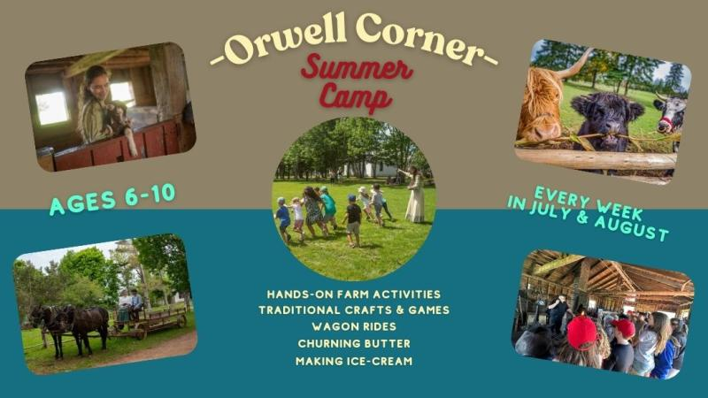
Your child will step back in time at the Orwell Corner Historic Village summer camps. Through hands-on activities, children will experience life as it was in the 1900s. From churning butter and making ice cream to blacksmithing and caring for farm animals, campers will have an experience like no other. Fun, learning, and a little time travel - all packed into an unforgettable week. Join us for old-fashioned rope making, wagon rides through the village, hands-on farm activities, traditional crafts, games and more!
Camps are Monday to Friday, 8:30 a.m. - 4:00 p.m. Ages 6-10. Campers are responsible for bringing their own snacks and lunch. Please ensure packed food items are peanut-free.
Visit https://www.peimuseum.ca/visit/orwell-corner-historic-village for registration
or more information, call us at (902) 651-8515 / (902) 368-6600 or email kevindmaclean@gov.pe.ca

- MacPhail Woods
Over the last 18 years, Macphail Woods has developed a unique approach to nature education.
Using an intuitive and practical approach to teaching, children of all ages can become birdwatchers, botanists and trackers. ​Giving kids positive experiences in nature builds confidence, excitement about being outside, and a deeper appreciation for the world around us.
We run day camps for children aged 6 to 16, covering topics from bird identification to swamp ecosystems to fire lighting. We go for hikes in the woods and in streams and marshes, hoot for owls, play games, explore the fields and woods around the property, and create art. We learn best through hands-on experience, and each camp is an adventure.
Our goal is to give campers an exciting but safe week. Small camp sizes and a high teacher-to-camper ratio as well as years of experience, are important factors in accomplishing this goal. Camp leaders are trained in first aid.
Camps:
Nature Discovery (6-8 year olds)
Becoming a Naturalist (8-10 year olds)
Young Ecologists (10-12 year olds)
Bushcraft Ecology (12-14 and 14-16 year olds)
Camp Runs from 9:00-3:00 every day, regardless of the weather at 269 Macphail Park Rd., Vernon Bridge PEI
Visit https://macphailwoods.org/education/childrens-camps for registration, prices, and dates

- Town of Stratford

Town of Stratford Summer Day Camp
- Ages: 6 to 12 years old
- Details: Features varying weekly themes, including crafts, games, and excursions. The town partners with local facilities (e.g., Stratford Rotary Complex and Agriplex) for daily recreation.
- Registration: Open online via the Town of Stratford Recreation Portal
Active Islanders Summer Camps
- Ages: 5 to 12 years old
- Details: These popular, physically active camps are led by local teachers and coaches. Activities emphasize traditional “gym class” style games, individual skills, and teamwork. Daily scheduling runs 9:00 a.m. to 4:00 p.m., with flexible drop-offs starting at 8:00 a.m..
- Registration: Book your child's spot on the Active Islanders Online Store at https://activeislanders.online/

- Camp Seggie
Seggie is more than games and laughter, it’s about growing, nurturing and developing. At Seggie, campers are removed from the distractions of this busy world. For a whole week, they are in a safe environment, unplugged from their computers, TV’s, video games, etc., and they experience love, acceptance and a message of hope. Our campers enjoy good meals, fresh air and plenty of exercise as they build encouraging relationships.

As much as they love our Rock Wall and Waterslide, we know that what keeps kids coming back to Camp year after year is our amazing staff. Our desire is to show Island kids the Love of God through caring for them, accepting them, singing songs and telling Bible Stories. We focus on building an intentional, caring relationship between our cabin leaders and campers. With each cabin home to both a Senior and at least one Junior Cabin Leader, our camps have a 5:1 ratio of campers to cabin leaders, ensuring each camper gets the time they deserve.

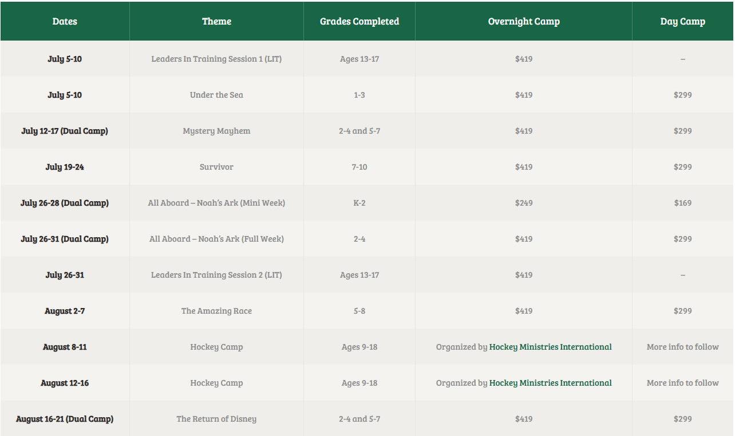

FULL WEEKS
Full Weeks Start Sunday at 6:30pm and end Friday at 4:00pm. They last six days and five nights.
DAY CAMPS
Day Camps for full week camps: Sunday 6:30pm-8:30pm; Monday-Thursday 9am-5pm; Friday 9am-4:00 pm
Campers that select this option do all the normal camp activities during the day but sleep at home during the night.
MINI WEEK
Mini Camps Lasts three days and two nights; Sunday at 4:30pm – Tuesday at 7:00pm
To register, go to campseggie.ca
If you have any questions at all, leave us a message at (902) 675-3799 or email us at campseggie@gmail.com

- Canoe Cove
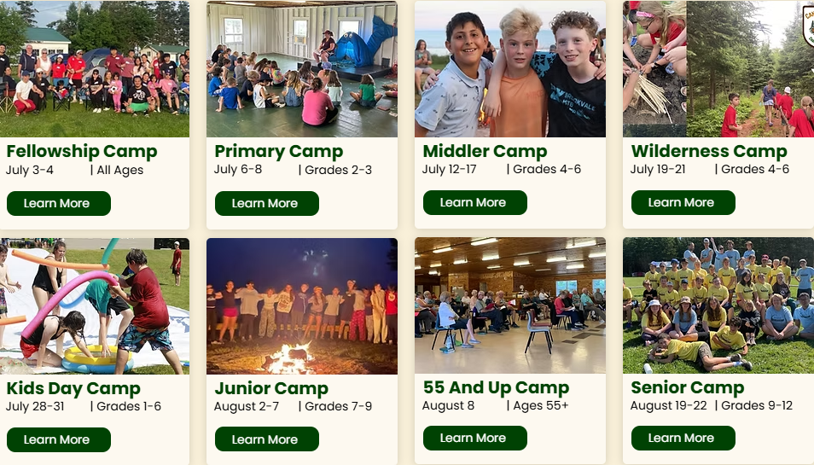
We are a faith based camp located on the beautiful south shores of Prince Edward Island. Here at The Cove, we strive to share the word of God in a safe and fun environment.

For more information and to register, go to canoecovechristiancamp.ca
Contact Us at 1-902-969-6888 or office@canoecovechristiancamp.ca
- Confederation Centre of the Arts
Our camps offer a creative outlet to explore various art forms and learn new skills. In our summer, winter break and PD day camps, youth can immerse themselves in fun-filled, educational experiences that include visual art, theatre, music, and more — all under the guidance of experienced instructors.
Confederation Centre of the Arts offers high-quality arts education for students of all ages and aspirations. Our programs are taught in a fun and safe environment that focuses on a positive learning process and teaching transferable life skills.
Classes are taught by highly qualified instructors with diverse and specialized skill sets, and programs are supported by outstanding facilities and extensive creative resources. From dancing to drawing to singing to sculpting, there are artistic opportunities for everyone at the Centre.
Camps run from June 29-August 20
For more information and to register, visit confederationcentre.com

- Dr. Tim Ogilvie AVC Vet Camp
The Atlantic Veterinary College’s Dr. Tim Ogilvie AVC Vet Camp (AVC Vet Camp) offers a behind-the-scenes peek into the world of veterinary medicine—from doing physical examinations on dogs and horses to learning how to dress like a surgeon and suturing on a silicon suture pad. You will be amazed at what you will see, learn, and do!
Camp activities are planned to ensure a balance of hands-on activities, lectures, labs, and discussions. You will meet some interesting animals, and you will explore the science of animals through sessions on pathology, bacteriology, anatomy, toxicology, and more! You will visit our large- and small-animal hospitals, take a couple of field trips, find out what learning to become a veterinarian involves, and learn how to keep your pets and farm animals healthy.
AVC Junior Vet camps are for students entering grades 7, 8, and 9 in the fall of 2026, and will be held from July 6-10, and July 13-17.
AVC Senior Vet camps are for students entering grades 10, 11, and 12 in the fall of 2026, and will be held from July 20-24, and July 27–31.
For more information, please visit https://www.upei.ca/avc/summer-programs/vetcamp

- Project Oceanology
Welcome to Project Oceanology! As a year‑round non‑profit marine science education organization, our mission comes to life each summer when the school year ends and our Marine Science Educators step into their roles as Camp Directors and staff. We are a CT licensed youth camp offering both day and overnight programs for campers ages 9–17, and since 1972, families have trusted us to provide meaningful, memorable summer experiences. Many campers return year after year—starting in day camp and later moving into residential programs—and we’re proud to welcome your family into this tradition.
At Project Oceanology, we believe in fostering a deep, lasting connection with the ocean and its ecosystems. Campers learn by doing: cruising Long Island Sound on our research vessel and fleet of skiffs, exploring salt marshes, and conducting hands‑on experiments in our marine labs. Along the way, they discover the creatures that call the Sound home and why protecting these environments matters.
Guided by professional marine scientists, campers build real skills in oceanography, biology, and environmental science. They measure water quality, collect marine organisms, and use oceanographic tools—all while participating in fun, team‑building activities that encourage collaboration, curiosity, and problem‑solving.
Our goal is to inspire responsibility and stewardship for the marine environment, empowering campers to become thoughtful advocates for the ocean’s future. We’re excited to share this journey with your family and look forward to an unforgettable summer of learning, adventure, and fun!
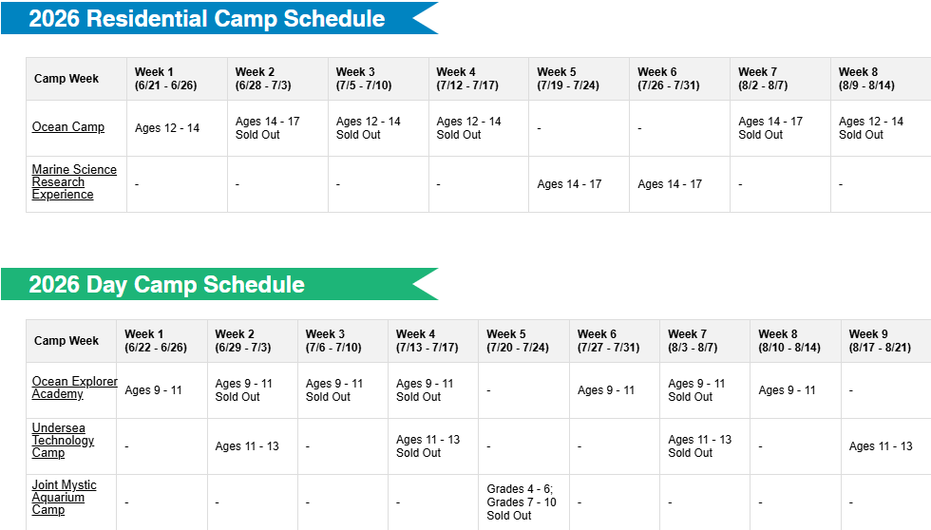
For more information and to register, visit https://www.oceanology.org/summer-camps

- PEI Soccer Association

Summer Camps - 2026
SUMMERSIDE SUMMER CAMP (Eric Johnson Turf Field)
$125/4 days
Assisted by PEIFC Youth Coaches and Goal Keeper Coach
July 20-23 (Monday-Thursday)
9am-12:30noon (drop off from 8:30-9am)
U9, U11 , U13
EASTERN EAGLES COMPLEX SUMMER CAMP
$125/4 days
Assisted by PEIFC Youth Coaches and Goal Keeper Coach
July 27 - 30 (Monday-Thursday)
9am-12:30noon (drop off from 8:30-9am)
U9 , U11 , U13
Visit https://www.peisoccer.com/content/summer-camps---2026 to register

- Junior Sailing – Charlottetown Yacht Club

The Junior Sailing Program at CYC is designed to teach participants how to sail by following the national CanSail levels. It is a two-week program where campers sail everyday, weather permitting. Participants will sail either with others in 420 sailboats, or alone or in pairs in Opti sailboats. The program can accommodate all levels of experience, and includes unique ‘Friday Fun Day’ events where participants sail to exciting locations once a week.
What Junior Sailing Course should my child be registered in?
If your child is 5-7 years old, he/she should register in Wet Feet.
If your child is 8+ and is new to sailing, he/she should register in Learn To Sail CANSail Levels 1 and 2.
Visit https://charlottetownyachtclubjuniorsailing.checklick.com/ for more information and to register
- Immigrant & Refugee Services Association PEI

Summer Program
The YSS Summer Program for students focuses on Canadian life skills, social support, and summer fun. It gives participants the chance to practice their English in an informal setting, learn about Canadian social norms, and learn more about Canada.
Students participate in scheduled activities such as art instruction, environmental studies, physical activity, and outings to historical, educational, and recreational venues. YSS also offers an overnight camping experience for teens.
Enrollment preference for the Summer Program is given to refugees and newly arrived student clients.
Visit https://www.irsapei.ca/en/programs-for-children for more info or contact them at 902-628-6009

- Storybook Adventures

Farm Animal Camp
Welcome to Farm Animal Camp! Your child's days will be filled with: caring for, and getting to know, our farm animals - their needs and unique personalities; animal and nature-based games that expand our awareness and understanding of the natural world and the challenges facing our environment; activities that foster kindness, compassion and community; personal and group challenges to build self-confidence and team spirit; storytelling and crafts, nature exploration and so much more!
Farm camps have weekly themes - even the weeks that share the same theme will include different games and activities so NO TWO CAMPS ARE EXACTLY ALIKE and kids can keep coming back week after week for more farm fun!
AGES 5 and up! Farm Camp runs 8:30 am to 4:30 pm
Early drop off is from 7:30 am and late pick up to 5 pm AT NO ADDITIONAL COST!
Storybook Equestrian Academy (SEA)
Junior Camp
Regular 5-day
Ages 7-10
Senior Camp
Regular 5-day
Ages 10 and up
Combined Camp
Regular 5-day
Ages 7 and up
For 20 years, Storybook Adventures has been a driving force in developing exceptional equestrian athletes in Prince Edward Island. We believe great riding begins with building a strong foundation - from the 'bottom' up. We also believe true horsemanship includes understanding the HORSE - from mechanics to communication and behavior. Producing confident, capable riders, who have respect and appreciation for horses, their peers and themselves, is our mission.
SEA is designed for riders of all levels, from beginners to advanced; from recreational riders to competitive. Whether you’re dreaming of sitting on a horse for the first time or one day, competing at the top of the sport, SEA provides the perfect platform to take your equestrian skills to the next level.
Each week, SEA includes daily riding lessons, stable management sessions, hands-on horsemanship skills, horse and camp-themed games and activities, culminating in a 'horse show' each Friday. We tailor each week to meet the needs of both beginners and aspiring athletes, all while creating a wonderful social atmosphere that promotes friendship, personal growth and fun!
Visit Storybook Adventures | Brookfield PEI online to register

- Red House Stables
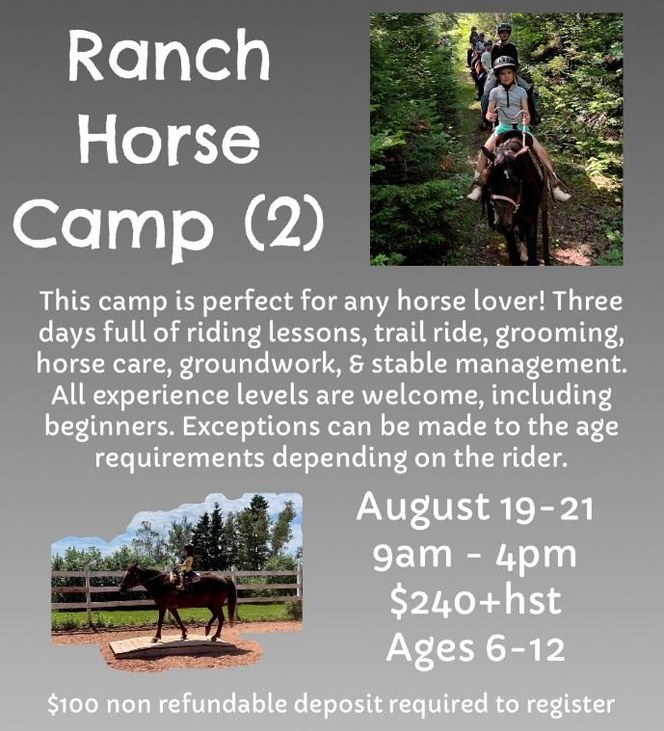
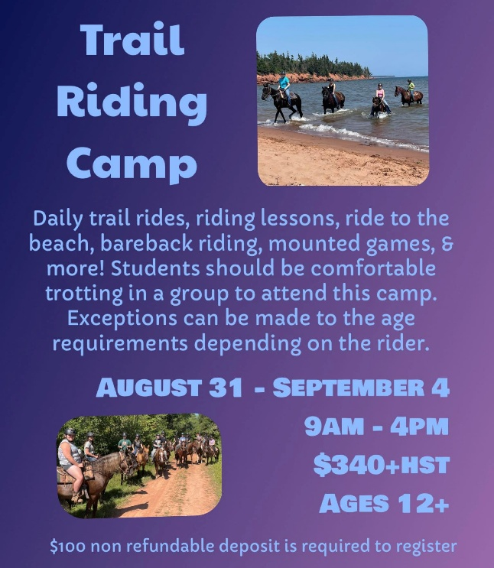
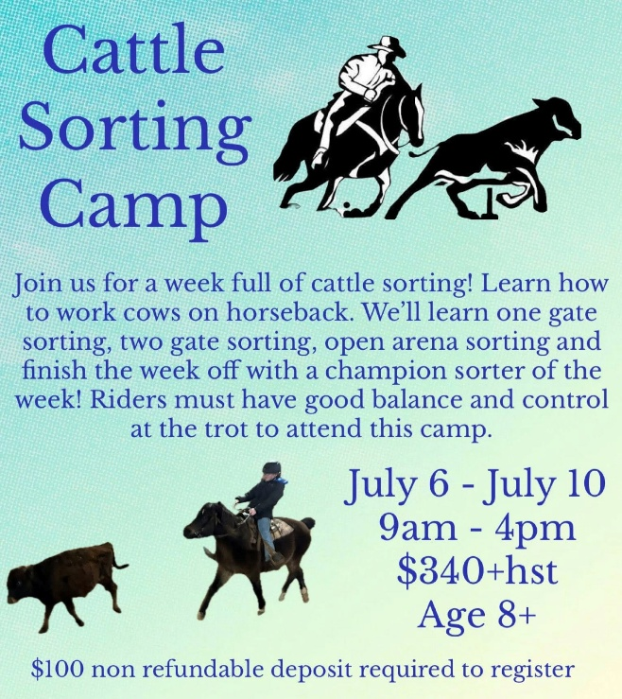

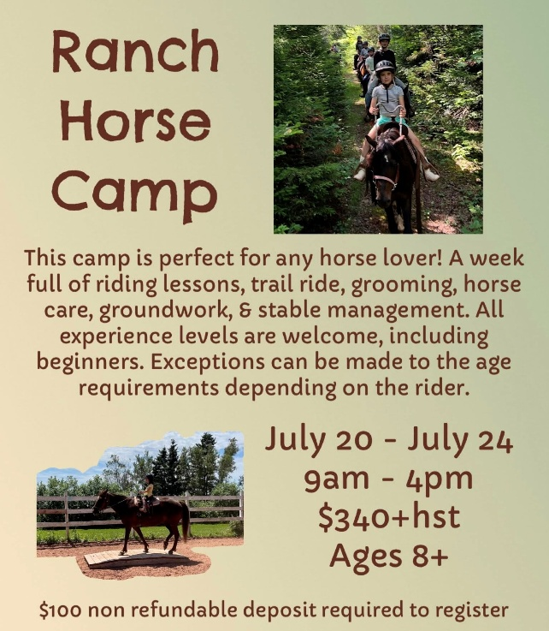
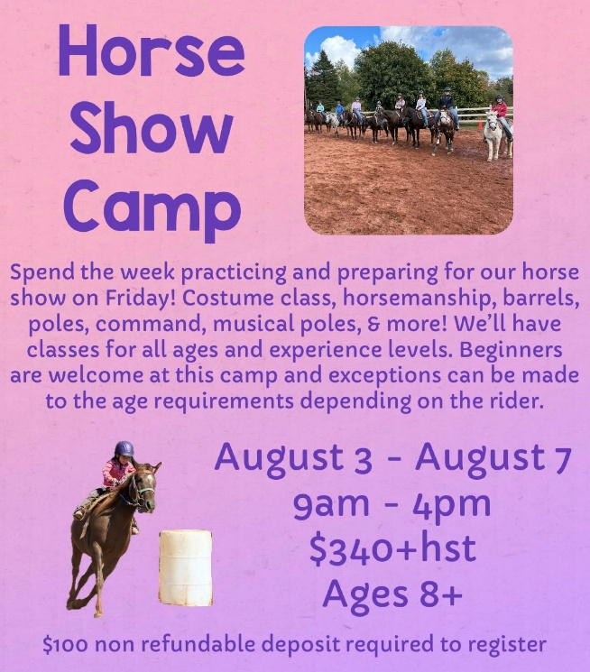

Call 902-215-8088 or email redhousestablespei@gmail.com to register

- Victory Gymnastics

Recreation Camp - Monday-Friday - Full day – 9-4 PM - $220
Competitive Camp – Monday-Friday
Half day – 1-4:30 - $185
Full day – 9 – 4 - $220
Email victorygymrec@gmail.com or call 902-892-1154 for more information or to register

- Lifesaving Society

The Lifesaving Society's Water Safety Day Camps operate throughout the summer and bring the Society's essential Swim, First Aid, Lifesaving and Lifeguard training programs to communities across Prince Edward Island.
Customized according to the age and skill levels of the participants, our week-long camps are taught by certified instructors who provide an enjoyable and educational experience for children in a safe and fun environment. Don't miss this opportunity to empower your child with lifelong skills while having a blast in the water this summer!
The Lifesaving Society's Water Safety Day Camps travel across Prince Edward Island for nine weeks throughout the summer to provide weeklong sessions to different communities across the province. The Day Camps feature two streams:
Swimming Lessons: designed for children ages 5+ who want to improve their swimming skills. Participants will progress through the Lifesaving Society's Swim for Life program. No previous swimming experience is necessary.
Lifeguard Academy: designed for adolescents ages 13+ who have previous swimming experience. Participants will complete the Society's Bronze Medallion, Bronze Cross and Standard First Aid courses - certifying them as Assistant Lifeguards and providing them with all the necessary prerequisites to register for the Lifesaving Society's National Lifeguard program.
To register, go to https://lifesavingsocietypei.ca/water-safety-day-camps.aspx

