HOW TO FIND YOUR CHILD’S BUS INFORMATION
To find your child’s bus information for September please check online at the following website: psbbusing.princeedwardisland.ca
Busing/Student information will not be available until mid-late June 2023.
The Transportation Services department is available to assist even in the summer months.
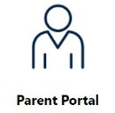
1. Click on
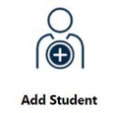
2. If you already have an account created, log in as normal and proceed to Step 4. Otherwise you will need to click Create Account and enter an email address.

4. Once you are logged in click on
3. Check your email inbox for an email from PSB Busing and follow the instructions to confirm your account and create a password. Please remember this information for future reference.

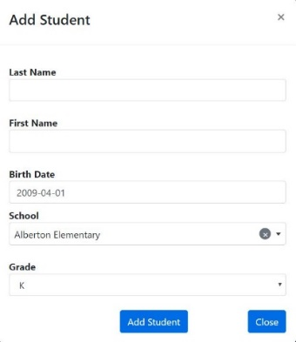
7. If you see information that needs to be changed, added or that you believe is incorrect, please click on the banner near the bottom of the site and fill in the requested information.

5. You will need to enter in the following information:

6. Next, click on This will display your child’s transportation details.

